**CHAPTER 8**

**BIBLIOGRAPHY**

**8.1 BOOKS**

1. "E-commerce for Dummies" by Don Jones and Mark D. Scott - This beginner-friendly guide offers practical advice on setting up and managing an e-commerce business, including tips on website design, product selection, and customer engagement.

2. "The Ultimate Guide to Online Shopping" by Jessica Butler - Explore this comprehensive book to gain insights into consumer behavior, online shopping trends, and strategies for optimizing the user experience on your gym products website.

3. "Marketing Strategies for Online Businesses" by Ryan Deiss and Russ Henneberry - Delve into effective digital marketing techniques tailored for e-commerce platforms, including SEO, social media marketing, email campaigns, and conversion optimization.

**8.2 WEBSITES**

1. Life Fitness - "Gym Equipment Manufacturers' Websites"

Website Link: https://www.lifefitness.com/

2. Amazon - "Customer Reviews and Testimonials Websites"

Website Link: <https://www.amazon.com/>

3. Matrix Fitness - "Gym Equipment Manufacturers' Websites"

Website Link: <https://www.matrixfitness.com/>

4. Rogue Fitness - "Fitness Products Selling Website"

Website Link: <https://www.roguefitness.com/>

5. Academy Sports + Outdoors - "Fitness Products Selling Website"

Website Link: https://www.academy.com/shop/browse/fitness

**APPENDIX A**

**SOFTWARE DESCRIPTION**

**WEB DEVELOPMENT WITH HTML, CSS, JAVASCRIPT, AND MYSQL**

**Table of Contents:**

1. Introduction to Web Development

2. HTML: Structuring Web Content

3. CSS: Styling Web Pages

4. JavaScript: Adding Interactivity

5. Introduction to Databases and MySQL

6. Setting Up MySQL Database

7. Connecting Frontend with Backend

8. Building Dynamic Web Applications

9. Security Considerations

10. Conclusion

**1. Introduction to Web Development:**

Web development encompasses the process of creating websites or web applications. It involves various technologies and languages to build both the frontend (client-side) and backend (server-side) components of a web application.

In this guide, we'll explore the fundamental tools and techniques used in web development, focusing on HTML, CSS, JavaScript for the frontend, and MySQL for backend data management.

2. **HTML: Structuring Web Content:**

HTML (HyperText Markup Language) serves as the foundation of web development, providing the structure and semantics for web pages. It consists of elements such as headings, paragraphs, lists, images, and links, which define the layout and content of a webpage.

We'll delve into the basic syntax of HTML, understanding tags, attributes, and the Document Object Model (DOM). Additionally, we'll explore advanced HTML features like forms, tables, and semantic elements for improved accessibility and SEO.

**3. CSS: Styling Web Pages:**

CSS (Cascading Style Sheets) enhances the presentation of HTML elements by applying styles such as colors, fonts, spacing, and layouts. It allows developers to create visually appealing and responsive designs across different devices and screen sizes.In this section, we'll discuss the principles of CSS, including selectors, properties, and values. We'll explore techniques for layout design, including Flexbox and Grid, and delve into advanced CSS features like animations and transitions for interactive user experiences.

**4. JavaScript: Adding Interactivity:**

JavaScript is a versatile programming language used for adding interactivity and dynamic behavior to web pages. It enables features such as form validation, DOM manipulation, event handling, and asynchronous requests (AJAX).

We'll cover the basics of JavaScript syntax, data types, functions, and control structures. Additionally, we'll explore modern JavaScript frameworks and libraries like React, Vue.js, and Angular for building complex frontend applications.

**5. Introduction to Databases and MySQL:**

Databases are essential for storing, retrieving, and managing data in web applications. MySQL is a popular relational database management system (RDBMS) known for its reliability, scalability, and performance.

We'll introduce the concept of databases, SQL (Structured Query Language), and relational database management systems. We'll discuss the features and benefits of MySQL and its role in backend data storage and retrieval.

**6. Setting Up MySQL Database:**

In this section, we'll walk through the process of setting up a MySQL database environment. We'll cover installation steps for MySQL Server, configuration options, and security considerations. Additionally, we'll explore tools like phpMyAdmin for database administration and management

**7. Connecting Frontend with Backend:**

Integration between the frontend and backend components of a web application is crucial for data exchange and communication. We'll discuss techniques for establishing connections between HTML/CSS/JavaScript frontend and MySQL backend using server-side languages like PHP, Node.js, or Python.

We'll explore concepts like RESTful APIs (Application Programming Interfaces), AJAX, and JSON (JavaScript Object Notation) for seamless data transmission between client and server.

**8. Building Dynamic Web Applications:**

With HTML, CSS, JavaScript, and MySQL in place, we can now build dynamic web applications that respond to user input and update data in real-time. We'll discuss architectural patterns like Model-View-Controller (MVC) and Single Page Applications (SPAs) for organizing code and managing application state.

We'll explore examples of dynamic web applications, including e-commerce platforms, social media sites, and content management systems (CMS), demonstrating how frontend and backend components interact to deliver rich user experiences.

**9. Security Considerations:**

Security is paramount in web development to protect against threats like cross-site scripting (XSS), SQL injection, and data breaches. We'll discuss best practices for securing web applications, including input validation, parameterized queries, HTTPS encryption, and user authentication/authorization mechanisms.

We'll explore security frameworks and libraries like OAuth, JWT (JSON Web Tokens), and encrypt for implementing robust authentication and authorization workflows.

**10. Conclusion:**

In conclusion, web development with HTML, CSS, JavaScript, and MySQL offers endless possibilities for creating interactive, data-driven applications. By mastering these technologies and principles, developers can build robust, scalable, and secure web solutions that meet the needs of modern users.

This comprehensive guide provides a detailed overview of web development principles and practices, covering frontend design, backend development, database management, and security considerations. By following these guidelines, developers can create powerful web applications that deliver exceptional user experiences and drive business growth.

**APPENDIX B**

**SOURCE CODE**

**SAMPLE SOURCE CODE**

<!DOCTYPE html>

<html>

<head>

<!-- Basic -->

<meta charset="utf-8" />

<meta http-equiv="X-UA-Compatible" content="IE=edge" />

<!-- Mobile Metas -->

<meta name="viewport" content="width=device-width, initial-scale=1, shrink-to-fit=no" />

<!-- Site Metas -->

<meta name="keywords" content="" />

<meta name="description" content="" />

<meta name="author" content="" />

<link rel="shortcut icon" href="images/favicon.png" type="">

<title>Unleash your strength</title>

<!-- bootstrap core css -->

<link rel="stylesheet" type="text/css" href="css/bootstrap.css" />

<!-- font awesome style -->

<link href="css/font-awesome.min.css" rel="stylesheet" />

<!-- Custom styles for this template -->

<link href="css/style.css" rel="stylesheet" />

<!-- responsive style -->

<link href="css/responsive.css" rel="stylesheet" />

</head>

<body>

<div class="hero_area">

<!-- header section strats -->

<header class="header_section" style="background-color:#256e5d; padding: 10px; color: #fff;">

<div class="container">

<nav class="navbar navbar-expand-lg custom_nav-container ">

<a class="navbar-brand" href="index.html"><img height="100" marginup="100px" width="150" src="images/logo.jpg" alt="#" /></a>

<button class="navbar-toggler" type="button" data-toggle="collapse" data-target="#navbarSupportedContent" aria-controls="navbarSupportedContent" aria-expanded="false" aria-label="Toggle navigation">

<span class=""> </span>

</button>

<div class="collapse navbar-collapse" id="navbarSupportedContent">

<ul class="navbar-nav">

<li class="nav-item active">

<a class="nav-link" href="index.html">Home </span></a>

</li>

<li class="nav-item">

<a class="nav-link" href="testimonal.html">Testimonal</a>

</li>

<li class="nav-item">

<a class="nav-link" href="product.html">Products</a>

</li>

<li class="nav-item">

<a class="nav-link" href="about.html">ABOUT US</a>

</li>

<li class="nav-item">

<a class="nav-link" href="contact.html">Contact</a>

</li>

<li class="nav-item">

<a class="nav-link" href="/Login_v15/loginindex.html">Logout</a>

</li>

<li class="nav-item">

<a class="nav-link" href="#">

<svg version="1.1" id="Capa_1" xmlns="http://www.w3.org/2000/svg" xmlns:xlink="http://www.w3.org/1999/xlink" x="0px" y="0px" viewBox="0 0 456.029 456.029" style="enable-background:new 0 0 456.029 456.029;" xml:space="preserve">

<g>

<g>

<path d="M345.6,338.862c-29.184,0-53.248,23.552-53.248,53.248c0,29.184,23.552,53.248,53.248,53.248

c29.184,0,53.248-23.552,53.248-53.248C398.336,362.926,374.784,338.862,345.6,338.862z" />

</g>

</g>

<g>

<g>

<path d="M439.296,84.91c-1.024,0-2.56-0.512-4.096-0.512H112.64l-5.12-34.304C104.448,27.566,84.992,10.67,61.952,10.67H20.48

C9.216,10.67,0,19.886,0,31.15c0,11.264,9.216,20.48,20.48,20.48h41.472c2.56,0,4.608,2.048,5.12,4.608l31.744,216.064

c4.096,27.136,27.648,47.616,55.296,47.616h212.992c26.624,0,49.664-18.944,55.296-45.056l33.28-166.4

C457.728,97.71,450.56,86.958,439.296,84.91z" />

</g>

</g>

<g>

<g>

<path d="M215.04,389.55c-1.024-28.16-24.576-50.688-52.736-50.688c-29.696,1.536-52.224,26.112-51.2,55.296

c1.024,28.16,24.064,50.688,52.224,50.688h1.024C193.536,443.31,216.576,418.734,215.04,389.55z" />

</g>

</g>

</g>

</g>

</g>

<g>

</g>

<g>

</g>

<g>

</g>

<g>

</g>

<g>

</g>

<g>

</g>

<g>

</g>

<g>

</g>

<g>

</g>

<g>

</g>

<g>

</g>

<g>

</g>

<g>

</g>

<g>

</g>

<g>

</g>

</svg>

</a>

</li>

<form class="form-inline">

<button class="btn  my-2 my-sm-0 nav_search-btn" type="submit">

<i class="fa fa-search" aria-hidden="true"></i>

</button>

</form>

</ul>

</div>

</nav>

</div>

</header>

<!-- end header section -->

<!-- slider section -->

<section class="slider_section ">

<div class="slider_bg_box">

<img src="images/slider-bg.jpg" alt="">

</div>

<div id="customCarousel1" class="carousel slide" data-ride="carousel">

<div class="carousel-inner">

<div class="carousel-item active">

<div class="container ">

<div class="row">

<div class="col-md-7 col-lg-6 ">

<div class="detail-box">

<h1 animation: moveEveryFiveSeconds 5s infinite>

<span>

Sale 20% Off

</span>

<br>

On Everything

</h1>

<div class="btn-box">

<!-- <a href="" class="btn1">

Shop Now

</a> -->

</div>

</div>

</div>

</div>

</div>

</div>

<div class="carousel-item ">

<div class="container ">

<div class="row">

<div class="col-md-7 col-lg-6 ">

<div class="detail-box">

<h1>

<span>

Unleash your potential

</span>

<br>

add to cart, achieve greatness

</h1>

<div class="btn-box">

<!-- <a href="" class="btn1">

Shop Now

</a> -->

</div>

</div>

</div>

</div>

</div>

</div>

<div class="carousel-item">

<div class="container ">

<div class="row">

<div class="col-md-7 col-lg-6 ">

<div class="detail-box">

<h1>

<span>

Your shopping journey starts now

</span>

<br>

Gear up, lift up.

</h1>

<p>

</p>

<div class="btn-box">

<!-- <a href="" class="btn1">

Shop Now

</a> -->

</div>

</div>

</div>

</div>

</div>

</div>

</div>

<div class="container">

<ol class="carousel-indicators">

<li data-target="#customCarousel1" data-slide-to="0" class="active"></li>

<li data-target="#customCarousel1" data-slide-to="1"></li>

<li data-target="#customCarousel1" data-slide-to="2"></li>

</ol>

</div>

</div>

</section>

<!-- end slider section -->

</div>

<!-- why section -->

<section class="why_section layout_padding">

<div class="container">

<div class="heading_container heading_center">

<h2>

Why Shop With Us

</h2>

</div>

<div class="row">

<div class="col-md-4">

<div class="box ">

<div class="img-box">

<svg version="1.1" id="Layer_1" xmlns="http://www.w3.org/2000/svg" xmlns:xlink="http://www.w3.org/1999/xlink" x="0px" y="0px" viewBox="0 0 512 512" style="enable-background:new 0 0 512 512;" xml:space="preserve">

<g>

<g>

<path d="M476.158,231.363l-13.259-53.035c3.625-0.77,6.345-3.986,6.345-7.839v-8.551c0-18.566-15.105-33.67-33.67-33.67h-60.392

V110.63c0-9.136-7.432-16.568-16.568-16.568H50.772c-9.136,0-16.568,7.432-16.568,16.568V256c0,4.427,3.589,8.017,8.017,8.017

c4.427,0,8.017-3.589,8.017-8.017V110.63c0-0.295,0.239-0.534,0.534-0.534h307.841c0.295,0,0.534,0.239,0.534,0.534v145.372

c0,4.427,3.589,8.017,8.017,8.017c4.427,0,8.017-3.589,8.017-8.017v-9.088h94.569c0.008,0,0.014,0.002,0.021,0.002

c0.008,0,0.015-0.001,0.022-0.001c11.637,0.008,21.518,7.646,24.912,18.171h-24.928c-4.427,0-8.017,3.589-8.017,8.017v17.102

c0,13.851,11.268,25.119,25.119,25.119h9.086v35.273h-20.962c-6.886-19.883-25.787-34.205-47.982-34.205

s-41.097,14.322-47.982,34.205h-3.86v-60.393c0-4.427-3.589-8.017-8.017-8.017c-4.427,0-8.017,3.589-8.017,8.017v60.391H192.817

c-6.886-19.883-25.787-34.205-47.982-34.205s-41.097,14.322-47.982,34.205H50.772c-0.295,0-0.534-0.239-0.534-0.534v-17.637

h34.739c4.427,0,8.017-3.589,8.017-8.017s-3.589-8.017-8.017-8.017H8.017c-4.427,0-8.017,3.589-8.017,8.017

s3.589,8.017,8.017,8.017h26.188v17.637c0,9.136,7.432,16.568,16.568,16.568h43.304c-0.002,0.178-0.014,0.355-0.014,0.534

c0,27.996,22.777,50.772,50.772,50.772s50.772-22.776,50.772-50.772c0-0.18-0.012-0.356-0.014-0.534h180.67

c-0.002,0.178-0.014,0.355-0.014,0.534c0,27.996,22.777,50.772,50.772,50.772c27.995,0,50.772-22.776,50.772-50.772

c0-0.18-0.012-0.356-0.014-0.534h26.203c4.427,0,8.017-3.589,8.017-8.017v-85.511C512,251.989,496.423,234.448,476.158,231.363z

M375.182,144.301h60.392c9.725,0,17.637,7.912,17.637,17.637v0.534h-78.029V144.301z M375.182,230.881v-52.376h71.235

l13.094,52.376H375.182z M144.835,401.904c-19.155,0-34.739-15.583-34.739-34.739s15.584-34.739,34.739-34.739

c19.155,0,34.739,15.583,34.739,34.739S163.99,401.904,144.835,401.904z M427.023,401.904c-19.155,0-34.739-15.583-34.739-34.739

s15.584-34.739,34.739-34.739c19.155,0,34.739,15.583,34.739,34.739S446.178,401.904,427.023,401.904z M495.967,299.29h-9.086

c-5.01,0-9.086-4.076-9.086-9.086v-9.086h18.171V299.29z" />

</g>

</g>

<g>

<g>

<path d="M144.835,350.597c-9.136,0-16.568,7.432-16.568,16.568c0,9.136,7.432,16.568,16.568,16.568

c9.136,0,16.568-7.432,16.568-16.568C161.403,358.029,153.971,350.597,144.835,350.597z" />

</g>

</g>

<g>

<g>

<path d="M427.023,350.597c-9.136,0-16.568,7.432-16.568,16.568c0,9.136,7.432,16.568,16.568,16.568

c9.136,0,16.568-7.432,16.568-16.568C443.591,358.029,436.159,350.597,427.023,350.597z" />

</g>

</g>

<g>

<g>

<path d="M332.96,316.393H213.244c-4.427,0-8.017,3.589-8.017,8.017s3.589,8.017,8.017,8.017H332.96

c4.427,0,8.017-3.589,8.017-8.017S337.388,316.393,332.96,316.393z" />

</g>

</g>

<g>

<g>

<path d="M127.733,282.188H25.119c-4.427,0-8.017,3.589-8.017,8.017s3.589,8.017,8.017,8.017h102.614

c4.427,0,8.017-3.589,8.017-8.017S132.16,282.188,127.733,282.188z" />

</g>

</g>

<g>

<g>

<path d="M278.771,173.37c-3.13-3.13-8.207-3.13-11.337,0.001l-71.292,71.291l-37.087-37.087c-3.131-3.131-8.207-3.131-11.337,0

c-3.131,3.131-3.131,8.206,0,11.337l42.756,42.756c1.565,1.566,3.617,2.348,5.668,2.348s4.104-0.782,5.668-2.348l76.96-76.96

C281.901,181.576,281.901,176.501,278.771,173.37z" />

</g>

</g>

<g>

</g>

<g>

</g>

<g>

</g>

<g>

</g>

<g>

</g>

<g>

</g>

<g>

</g>

<g>

</g>

<g>

</g>

<g>

</g>

<g>

</g>

<g>

</g>

<g>

</g>

<g>

</g>

<g>

</g>

</svg>

</div>

<div class="detail-box">

<h5>

Fast Delivery

</h5>

<p>

Swift gains, faster delivery – fitness at your doorstep;

</p>

</div>

</div>

</div>

<div class="col-md-4">

<div class="box ">

<div class="img-box">

<svg version="1.1" id="Capa_1" xmlns="http://www.w3.org/2000/svg" xmlns:xlink="http://www.w3.org/1999/xlink" x="0px" y="0px" viewBox="0 0 490.667 490.667" style="enable-background:new 0 0 490.667 490.667;" xml:space="preserve">

<g>

<g>

<path d="M138.667,192H96c-5.888,0-10.667,4.779-10.667,10.667V288c0,5.888,4.779,10.667,10.667,10.667s10.667-4.779,10.667-10.667

v-74.667h32c5.888,0,10.667-4.779,10.667-10.667S144.555,192,138.667,192z" />

</g>

</g>

<g>

<g>

<path d="M117.333,234.667H96c-5.888,0-10.667,4.779-10.667,10.667S90.112,256,96,256h21.333c5.888,0,10.667-4.779,10.667-10.667

S123.221,234.667,117.333,234.667z" />

</g>

</g>

<g>

<g>

<path d="M245.333,0C110.059,0,0,110.059,0,245.333s110.059,245.333,245.333,245.333s245.333-110.059,245.333-245.333

S380.608,0,245.333,0z M245.333,469.333c-123.52,0-224-100.48-224-224s100.48-224,224-224s224,100.48,224,224

S368.853,469.333,245.333,469.333z" />

</g>

</g>

<g>

<g>

<path d="M386.752,131.989C352.085,88.789,300.544,64,245.333,64s-106.752,24.789-141.419,67.989

c-3.691,4.587-2.965,11.307,1.643,14.997c4.587,3.691,11.307,2.965,14.976-1.643c30.613-38.144,76.096-60.011,124.8-60.011

s94.187,21.867,124.779,60.011c2.112,2.624,5.205,3.989,8.32,3.989c2.368,0,4.715-0.768,6.677-2.347

C389.717,143.296,390.443,136.576,386.752,131.989z" />

</g>

</g>

<g>

<g>

<path d="M376.405,354.923c-4.224-4.032-11.008-3.861-15.061,0.405c-30.613,32.235-71.808,50.005-116.011,50.005

s-85.397-17.771-115.989-50.005c-4.032-4.309-10.816-4.437-15.061-0.405c-4.309,4.053-4.459,10.816-0.405,15.083

c34.667,36.544,81.344,56.661,131.456,56.661s96.789-20.117,131.477-56.661C380.864,365.739,380.693,358.976,376.405,354.923z" />

</g>

</g>

<g>

<g>

<path d="M206.805,255.723c15.701-2.027,27.861-15.488,27.861-31.723c0-17.643-14.357-32-32-32h-21.333

c-5.888,0-10.667,4.779-10.667,10.667v42.581c0,0.043,0,0.107,0,0.149V288c0,5.888,4.779,10.667,10.667,10.667

S192,293.888,192,288v-16.917l24.448,24.469c2.091,2.069,4.821,3.115,7.552,3.115c2.731,0,5.461-1.045,7.531-3.136

c4.16-4.16,4.16-10.923,0-15.083L206.805,255.723z M192,234.667v-21.333h10.667c5.867,0,10.667,4.779,10.667,10.667

s-4.8,10.667-10.667,10.667H192z" />

</g>

</g>

<g>

<g>

<path d="M309.333,277.333h-32v-64h32c5.888,0,10.667-4.779,10.667-10.667S315.221,192,309.333,192h-42.667

c-5.888,0-10.667,4.779-10.667,10.667V288c0,5.888,4.779,10.667,10.667,10.667h42.667c5.888,0,10.667-4.779,10.667-10.667

S315.221,277.333,309.333,277.333z" />

</g>

</g>

<g>

<g>

<path d="M288,234.667h-21.333c-5.888,0-10.667,4.779-10.667,10.667S260.779,256,266.667,256H288

c5.888,0,10.667-4.779,10.667-10.667S293.888,234.667,288,234.667z" />

</g>

</g>

<g>

<g>

<path d="M394.667,277.333h-32v-64h32c5.888,0,10.667-4.779,10.667-10.667S400.555,192,394.667,192H352

c-5.888,0-10.667,4.779-10.667,10.667V288c0,5.888,4.779,10.667,10.667,10.667h42.667c5.888,0,10.667-4.779,10.667-10.667

S400.555,277.333,394.667,277.333z" />

</g>

</g>

<g>

<g>

<path d="M373.333,234.667H352c-5.888,0-10.667,4.779-10.667,10.667S346.112,256,352,256h21.333

c5.888,0,10.667-4.779,10.667-10.667S379.221,234.667,373.333,234.667z" />

</g>

</g>

<g>

</g>

<g>

</g>

<g>

</g>

<g>

</g>

<g>

</g>

<g>

</g>

<g>

</g>

<g>

</g>

<g>

</g>

<g>

</g>

<g>

</g>

<g>

</g>

<g>

</g>

<g>

</g>

<g>

</g>

</svg>

</div>

<div class="detail-box">

<h5>

Free Shiping

</h5>

<p>

Where quality meets the journey: Free shipping on every lift.

</p>

</div>

</div>

</div>

<div class="col-md-4">

<div class="box ">

<div class="img-box">

<svg id="_30_Premium" height="512" viewBox="0 0 512 512" width="512" xmlns="http://www.w3.org/2000/svg" data-name="30_Premium">

<g id="filled">

<path d="m252.92 300h3.08a124.245 124.245 0 1 0 -4.49-.09c.075.009.15.023.226.03.394.039.789.06 1.184.06zm-96.92-124a100 100 0 1 1 100 100 100.113 100.113 0 0 1 -100-100z" />

<path d="m447.445 387.635-80.4-80.4a171.682 171.682 0 0 0 60.955-131.235c0-94.841-77.159-172-172-172s-172 77.159-172 172c0 73.747 46.657 136.794 112 161.2v158.8c-.3 9.289 11.094 15.384 18.656 9.984l41.344-27.562 41.344 27.562c7.574 5.4 18.949-.7 18.656-9.984v-70.109l46.6 46.594c6.395 6.789 18.712 3.025 20.253-6.132l9.74-48.724 48.725-9.742c9.163-1.531 12.904-13.893 6.127-20.252zm-339.445-211.635c0-81.607 66.393-148 148-148s148 66.393 148 148-66.393 148-148 148-148-66.393-148-148zm154.656 278.016a12 12 0 0 0 -13.312 0l-29.344 19.562v-129.378a172.338 172.338 0 0 0 72 0v129.38zm117.381-58.353a12 12 0 0 0 -9.415 9.415l-6.913 34.58-47.709-47.709v-54.749a171.469 171.469 0 0 0 31.467-15.6l67.151 67.152z" />

<path d="m287.62 236.985c8.349 4.694 19.251-3.212 17.367-12.618l-5.841-35.145 25.384-25c7.049-6.5 2.89-19.3-6.634-20.415l-35.23-5.306-15.933-31.867c-4.009-8.713-17.457-8.711-21.466 0l-15.933 31.866-35.23 5.306c-9.526 1.119-13.681 13.911-6.634 20.415l25.384 25-5.841 35.145c-1.879 9.406 9 17.31 17.367 12.618l31.62-16.414zm-53-32.359 2.928-17.615a12 12 0 0 0 -3.417-10.516l-12.721-12.531 17.658-2.66a12 12 0 0 0 8.947-6.5l7.985-15.971 7.985 15.972a12 12 0 0 0 8.947 6.5l17.658 2.66-12.723 12.535a12 12 0 0 0 -3.417 10.516l2.928 17.615-15.849-8.231a12 12 0 0 0 -11.058 0z" />

</g>

</svg>

</div>

<div class="detail-box">

<h5>

Best Quality

</h5>

<p>

Elevate your fitness: Quality that speaks volumes.

</p>

</div>

</div>

</div>

</div>

</div>

</section>

<!-- end why section -->

<!-- arrival section -->

<section class="arrival_section">

<div class="container">

<div class="box">

<div class="arrival_bg_box">

<img src="images/arrival-bg.jpg" alt="">

</div>

<div class="row">

<div class="col-md-6 ml-auto">

<div class="heading_container remove_line_bt">

<h2>

#NewArrivalsonclick

</h2>

</div>

<p style="margin-top: 20px;margin-bottom: 30px;">

"Experience the thrill of fresh fitness vibes with our newest arrivals! Elevate your workout game and embrace the latest in activewear trends. Discover comfort, style, and innovation in every piece. Dive into our collection and stay ahead in your fitness journey!"

<!-- <a href="">

Shop Now

</a> -->

</div>

</div>

</div>

</div>

</section>

<!-- end arrival section -->

<!-- product section -->

<section class="product_section layout_padding">

<div class="container">

<div class="heading_container heading_center">

<h2>

Our <span>products</span>

</h2>

</div>

<div class="row">

<div class="col-sm-6 col-md-4 col-lg-4">

<div class="box">

<div class="option_container">

<div class="options">

<a href="#" class="option1" onclick="addToCart()">Add to Cart</a>

<a href="#" class="option2" onclick="buyNow()">Buy Now</a>

</div>

</div>

<div class="img-box">

<img src="images/p1.png" alt="">

</div>

<div class="detail-box">

<h5>

Barbells 20kg

</h5>

<h6>

₹750

</h6>

</div>

</div>

</div>

<div class="col-sm-6 col-md-4 col-lg-4">

<div class="box">

<div class="option_container">

<div class="options">

<a href="" class="option1">

Add To Cart

</a>

<a href="" class="option2">

Buy Now

</a>

</div>

</div>

<div class="img-box">

<img src="images/p2.png" alt="">

</div>

<div class="detail-box">

<h5>

Dumbbells 30 kgs(3X10)

</h5>

<h6>

₹800

</h6>

</div>

</div>

</div>

<div class="col-sm-6 col-md-4 col-lg-4">

<div class="box">

<div class="option_container">

<div class="options">

<a href="" class="option1">

Add To Cart

</a>

<a href="" class="option2">

Buy Now

</a>

</div>

</div>

<div class="img-box">

<img src="images/p3.png" alt="">

</div>

<div class="detail-box">

<h5>

Skipping ropes (2 pairs)

</h5>

<h6>

₹680

</h6>

</div>

</div>

</div>

<div class="col-sm-6 col-md-4 col-lg-4">

<div class="box">

<div class="option_container">

<div class="options">

<a href="" class="option1">

Add To Cart

</a>

<a href="" class="option2">

Buy Now

</a>

</div>

</div>

<div class="img-box">

<img src="images/p4.png" alt="">

</div>

<div class="detail-box">

<h5>

Kettlebell(25kgs)

</h5>

<h6>

₹700

</h6>

</div>

</div>

</div>

<div class="col-sm-6 col-md-4 col-lg-4">

<div class="box">

<div class="option_container">

<div class="options">

<a href="" class="option1">

Add To Cart

</a>

<a href="" class="option2">

Buy Now

</a>

</div>

</div>

<div class="img-box">

<img src="images/p5.png" alt="">

</div>

<div class="detail-box">

<h5>

Treadmill

</h5>

<h6>

₹750

</h6>

</div>

</div>

</div>

<div class="col-sm-6 col-md-4 col-lg-4">

<div class="box">

<div class="option_container">

<div class="options">

<a href="" class="option1">

Add To Cart

</a>

<a href="" class="option2">

Buy Now

</a>

</div>

</div>

<div class="img-box">

<img src="images/p6.png" alt="">

</div>

<div class="detail-box">

<h5>

Exercise Spinning Bike

</h5>

<h6>

₹580

</h6>

</div>

</div>

</div>

<div class="container">

<div class="btn-box">

<a href="product.html">View all products</a>

</div>

<div></div>

</div>

</section>

<!-- end product section -->

<!-- arrival2 section -->

<section class="arrival_section">

<div class="container">

<div class="box">

<div class="arrival_bg_box">

<img src="images/ban2.png" width="250" alt="">

</div>

<div class="row">

<div class="col-md-6 ml-auto">

<div class="heading_container remove_line_bt">

<h2>

#Innovation Zone

</h2>

</div>

<p style="margin-top: 20px;margin-bottom: 30px;">

"Step into the 'Innovation Zone' where every workout becomes a journey of progress. Unleash the power of cutting-edge fitness gear designed to elevate your exercise experience. Embrace innovation, break boundaries, and redefine your fitness routine. Your path to peak performance starts here, in the heart of the Innovation Zone."

<!-- <a href="">

Shop Now

</a> -->

</div>

</div>

</div>

</div>

</section>

<!-- end arrival2 section -->

<!-- subscribe section -->

<section class="subscribe_section">

<div class="container-fuild">

<div class="box">

<div class="row">

<div class="col-md-6 offset-md-3">

<div class="subscribe_form ">

<div class="heading_container heading_center">

<h3>Subscribe To Get Discount Offers</h3>

</div>

<p>Subscribe now and unlock a world of exclusive discounts delivered straight to your inbox. Join us on the journey to savings and style – your fitness goals just got more affordable!</p>

<form action="">

<input type="email" placeholder="Enter your email">

<button>

subscribe

</button>

</form>

</div>

</div>

</div>

</div>

</div>

</section>

<!-- end subscribe section -->

<!-- client section -->

<section class="client_section layout_padding">

<div class="container">

<div class="heading_container heading_center">

<h2>

Customer's Testimonial

</h2>

</div>

<div id="carouselExample3Controls" class="carousel slide" data-ride="carousel">

<div class="carousel-inner">

<div class="carousel-item active">

<div class="box col-lg-10 mx-auto">

<div class="img_container">

<div class="img-box">

<div class="img_box-inner">

<img src="images/jennie.jpg" alt="">

</div>

</div>

</div>

<div class="detail-box">

<h5>

Jennie kim

</h5>

<h6>

Seoul, Korea

</h6>

<p>

"Absolutely thrilled with my purchase! The gym workout products I bought online exceeded my expectations. Top-notch quality, prompt delivery, and a seamless shopping experience. Highly recommend!"

</p>

</div>

</div>

</div>

<div class="carousel-item">

<div class="box col-lg-10 mx-auto">

<div class="img_container">

<div class="img-box">

<div class="img_box-inner">

<img src="images/damon.jpg" alt="">

</div>

</div>

</div>

<div class="detail-box">

<h5>

Damon Salvatore

</h5>

<h6>

Mystic Falls

</h6>

<p>

"Impressed with the variety and quality of workout gear. The online buying process was smooth, and my order arrived sooner than expected. Will definitely be a repeat customer for my fitness needs."

</p>

</div>

</div>

</div>

<div class="carousel-item">

<div class="box col-lg-10 mx-auto">

<div class="img_container">

<div class="img-box">

<div class="img_box-inner">

<img src="images/klaus.jpg" alt="">

</div>

</div>

</div>

<div class="detail-box">

<h5>

Klaus Mikaelson

</h5>

<h6>

New Orleands

</h6>

<p>

"Fantastic selection of gym products! Ordering online was a breeze, and the items received were exactly as described. The customer service was exceptional too. I'm a satisfied customer and will be coming back for more."

</p>

</div>

</div>

</div>

</div>

<div class="carousel_btn_box">

<a class="carousel-control-prev" href="#carouselExample3Controls" role="button" data-slide="prev">

<i class="fa fa-long-arrow-left" aria-hidden="true"></i>

<span class="sr-only">Previous</span>

</a>

<a class="carousel-control-next" href="#carouselExample3Controls" role="button" data-slide="next">

<i class="fa fa-long-arrow-right" aria-hidden="true"></i>

<span class="sr-only">Next</span>

</a>

</div>

</div>

</div>

</section>

<!-- end client section -->

<!-- footer start -->

<footer>

<div class="container">

<div class="row">

<div class="col-md-4">

<div class="full">

<div class="logo_footer">

<a href="#"><img height="1px" width="1px" src="images/logo.jpg" alt="#" /></a>

</div>

<div class="information_f">

<p><strong>ADDRESS:</strong> 58, Arunachalam Nagar, Kondur, Cudalore, TamilNadu 607001</p>

<p><strong>TELEPHONE:</strong> +91 98430 59884</p>

<p><strong>EMAIL:</strong> vishvajitr2002@gmail.com</p>

</div>

</div>

</div>

<div class="col-md-8">

<div class="row">

<div class="col-md-7">

<div class="row">

<div class="col-md-6">

<div class="widget_menu">

<h3>Menu</h3>

<ul>

<li><a href="#">Home</a></li>

<li><a href="#">Services</a></li>

<li><a href="#">Testimonial</a></li>

<li><a href="#">ABOUT US</a></li>

<li><a href="#">Contact</a></li>

</ul>

</div>

</div>

<div class="col-md-6">

<div class="widget_menu">

<h3>Account</h3>

<ul>

<li><a href="#">Account</a></li>

<li><a href="#">Checkout</a></li>

<li><a href="#">Login</a></li>

<li><a href="#">Register</a></li>

<li><a href="#">Shopping</a></li>

<li><a href="#">Widget</a></li>

</ul>

</div>

</div>

</div>

</div>

<div class="col-md-5">

<div class="widget_menu">

<h3>Newsletter</h3>

<div class="information_f">

<p>"Subscribe for exclusive fitness perks!</p>

</div>

<div class="form_sub">

<form>

<fieldset>

<div class="field">

<input type="email" placeholder="Enter Your Mail" name="email" />

<input type="submit" value="Subscribe" />

</div>

</fieldset>

</form>

</div>

</div>

</div>

</div>

</div>

</div>

</div>

</footer>

<!-- footer end -->

<div class="cpy_">

<p class="mx-auto">© 2024 All Rights Reserved By <a>Vishvajit & Vijay Kumar</a><br></p>

</div>

<!-- jQery -->

<script src="js/jquery-3.4.1.min.js"></script>

<!-- popper js -->

<script src="js/popper.min.js"></script>

<!-- bootstrap js -->

<script src="js/bootstrap.js"></script>

<!-- custom js -->

<script src="js/custom.js"></script>

</body>

</html>

**APPENDIX C**

**SCREENSHOTS**

Home page

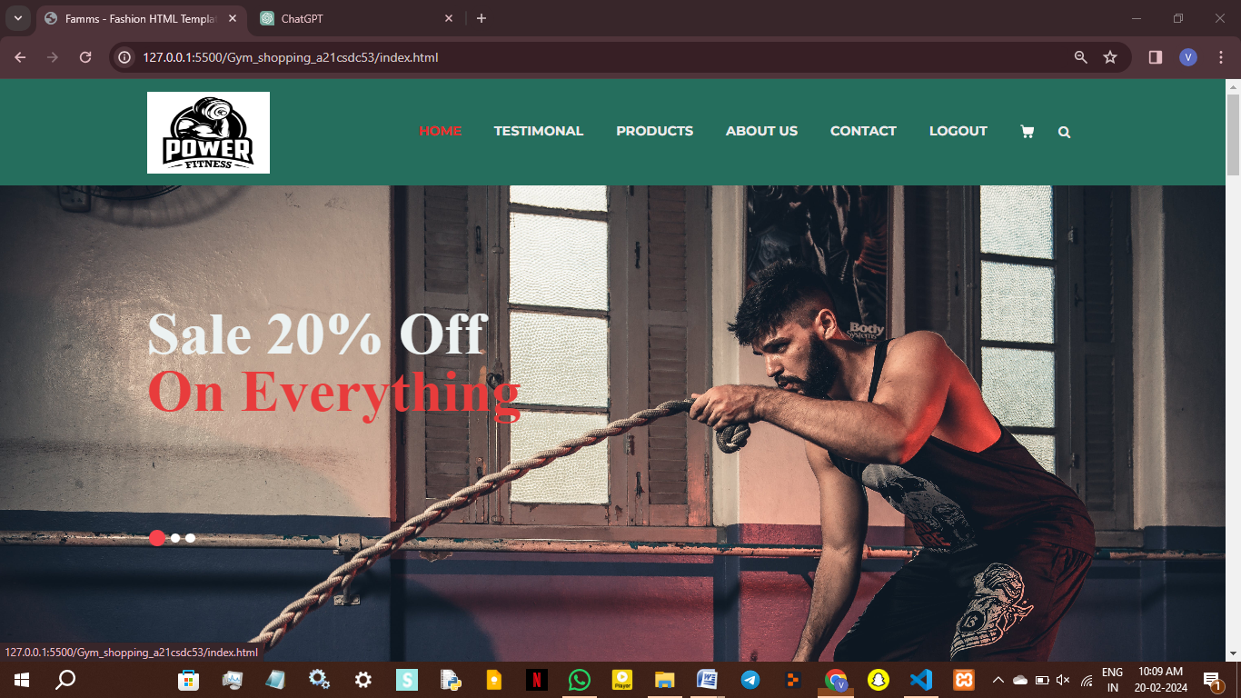

products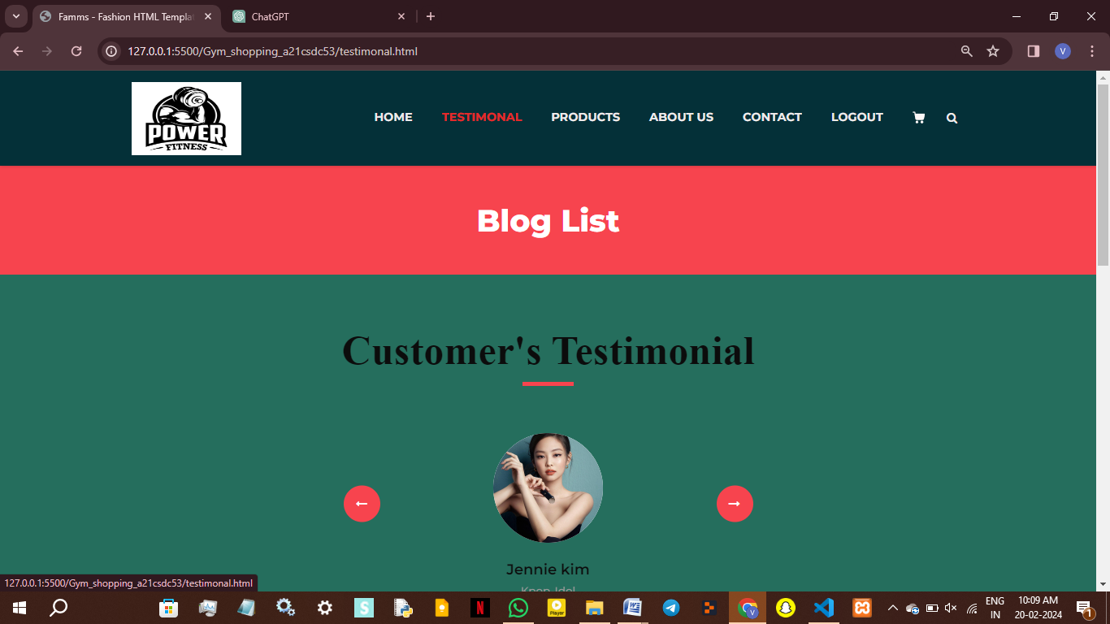

Customer Testimonal

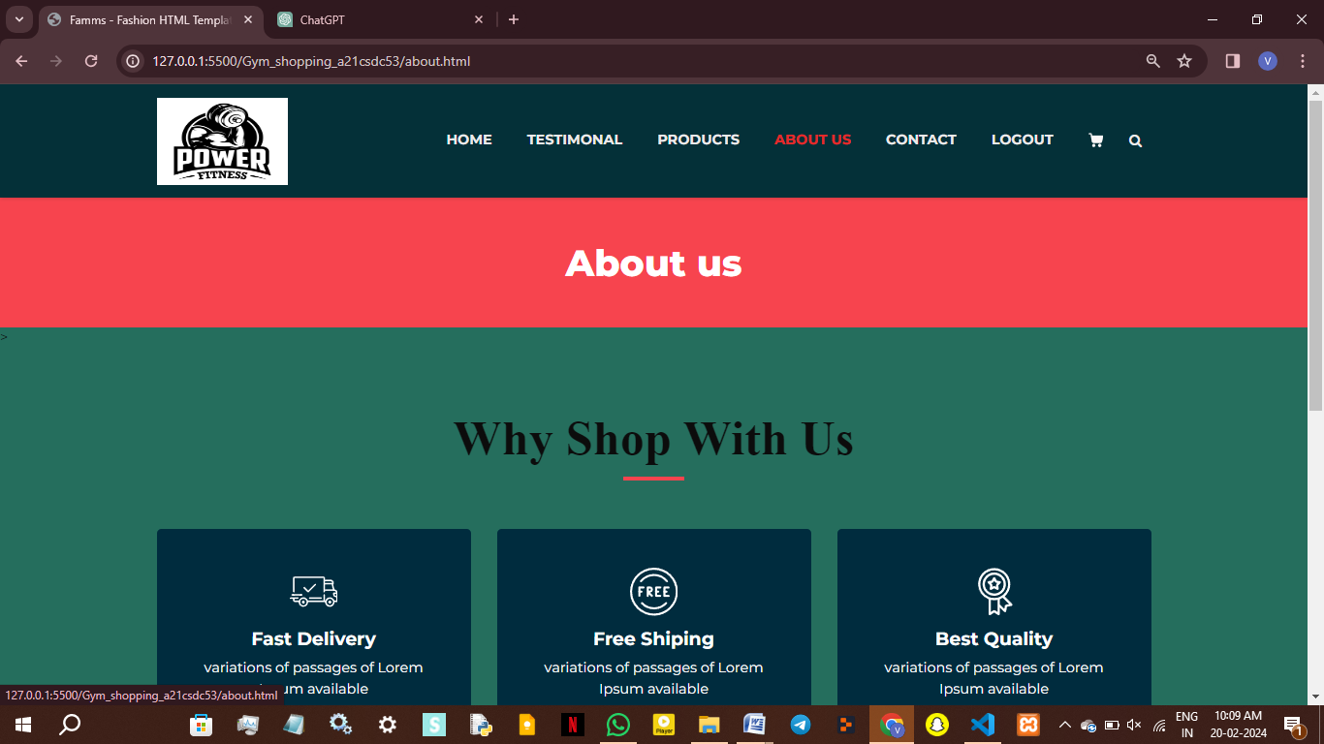

Contact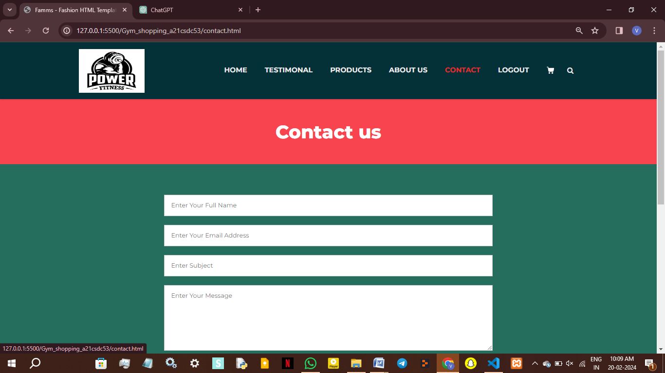

Login

